**Adobe Photoshop CS5 Chapter 3 Test Notes**

1. The Layers panel includes the following different kinds of layers except portrait.

2. The layers panel is where all the layers in a Photoshop file are displayed.

3. The thumbnail display can be turned off in the Layers panel.

4. The layer thumbnail component of the Layers panel can show a miniature image of a layer's contents.

5. You can change the location of the Layers panel on the screen by dragging the panel’s tab.

6. A layer thumbnail can be turned on or off, can be resized, and is a miniature image of the layer's contents.

7. The layers panel is the area/feature that is used to resize a layer thumbnail.

8. The Layers Panel Options dialog box is used to turn off the thumbnail display.

9. The background layer cannot be modified extensively.

10. The background layer is always at the bottom of a stack.

11. On the Layers panel, the Background layer is found at the bottom of the list.

12. Centimeters and rasters are not units of measurement for rulers.

13. The pixel unit of measurement makes it easiest to make small adjustments.

14. Edit (Win) or Photoshop (Mac) menu commands allow you to change your units of measurements preference.

15. You can NOT create a layer by clicking rasterize on the New Layer menu panel dialog box.

16. Opacity determines the percentage of transparency in a layer.

17. The layers panel can be used to create a layer.

18. A layer cannot be deleted by clicking layer on the toolbar, clicking delete, then clicking \ the unwanted layer.

19. You can restore a deleted layer during the current editing session by deleting the delete layer state on the History panel.

20. Exclude certain parts of an image from view by using the crop tool.

21. Hiding portions of an image without losing resolution quality is not called hiding, shielding, or concealing.

22. An area in an image that is surrounded by a marquee is called a selection.

23. A dashed line that surrounds an area is called a marquee.

24. The move tool can be used to move a selection.

25. The Move Tool is located on the tools panel.

26. You can duplicate a layer.

27. There is 1 layer in a flattened file.

28. When an image is flattened, all visible layers are combined in the background layer.

29. The layer menu is used to flatten an image.

30. A file's size can be significantly reduced using the flattening process.

31. Visible layers are included in a flattened file.

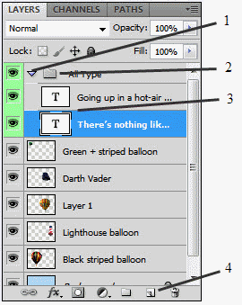

32. In the figure above, figure 2 refers to the Layer Group Icon.

33. In the figure above, figure 3 refers to the layers that are within a group?

34. The layer group is expanded is referred to by the number 1 in the figure above?

35. In the figure above, number 4 refers to creating a new layer.